7 Emerging Tech Trends That Are Changing the Sports Marketing Game
SportTechie Wire August 5, 2016August 7, 2016 Guest
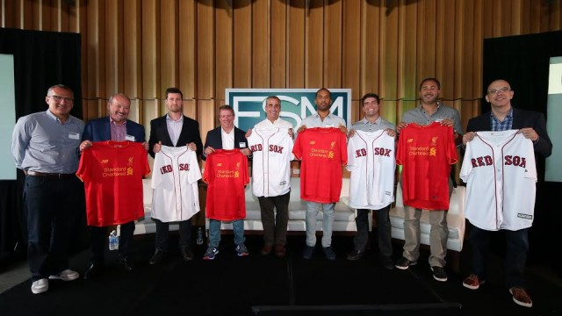(Courtesy of Fenway Sports Management)
Fenway Sports Management brings leading technology, new media, performance fitness and professional sports executives together to explore how technology is transforming the fan and brand experience at summit in Silicon Valley
SANTA CLARA, Calif. – Fenway Sports Management (FSM), a global sports marketing firm that specializes in partnership sales, consulting and special events, hosted sports and tech industry leaders for a conversation on the ways in which digital innovation is redefining the sports experience at its “Changing the Game” summit.
The event featured a keynote from Facebook Head of Global Sports Partnerships Dan Reed and informative sessions led by Intel Corp. CEO Brian Krzanich, New Balance President and CEO Rob DeMartini, STRIVR Labs Founder and CEO Derek Belch, EA Chief Competition Officer Peter Moore, NRG eSports Chairman and Cofounder and Sacramento Kings Co-owner Andrew Miller, and SpringHill Entertainment and Uninterrupted Cofounder and CEO Maverick Carter. Recode Senior Editor Kurt Wagner and FSM Managing Director Mark Lev served as moderator and host, respectively, for the summit, which took place on Friday, July 29, at Levi’s Stadium in Santa Clara, Calif.
“Our intent for the summit was to convene executive leaders from innovative brands that are transforming the sports industry for an engaging conversation on the emerging trends that are fueling these advancements, and to share innovative strategies that will help brands navigate this rapidly evolving landscape,” said Lev.
Here are seven important trends for sports marketers that emerged from the FSM-led conversations:
- Brands must develop robust “second screen” social media strategies to engage fans during game broadcasts. Social media is a proven driver for television broadcasts, which continue to be major revenue drivers for teams, networks and advertising brands. According to Nielsen, each time a Facebook post about an NFL game broadcast is shared during the 15 minutes prior to kickoff, 1,000 additional viewers tune in for the first minute of play.
- While content is king, video will rule the content universe in the near future. Video and photos provide opportunity for brands to deliver entertaining, exclusive content and drive greater fan engagement. One hundred million hours of video are viewed per day on Facebook, and videos average 62 percent more engagement than photos.
- The long-heralded era of wearable technology has arrived. Consumers of performance wear will increasingly demand both style and advanced functionality, driving sports and fitness clothing, footwear and equipment manufacturers and technology providers to partner to incorporate smart technologies into athletic products. New Balance and Intel Corp. recently announced a strategic collaboration to create products that connect athletes with technology, disclosing plans to jointly develop a smart sport watch scheduled for the 2016 holiday season.
- Advanced video technology will transform the way sports are governed and experienced. Real-time athlete data and enhanced replay technology will provide a bevy of new information for leagues, teams, broadcasters and fans. Intel piloted its 360-degree replay technology during MLB All-Star Weekend to create near-360-degree, 3-D replays of action on the field during live broadcasts on ESPN, FOX and MLB Network. It also integrated its Intel Curie module into select snowboard and BMX competitions in the ESPN X Games to provide real-time data on in-air rotations, jump height, speed and force on landing.
- Virtual reality is the future and the future is now – VR will revolutionize player training and fan engagement.VR’s ability to capture the first-person point of view has valuable applications that traditional video lacks: Athletes get valuable repetitions from a first-person perspective in an immersive, 360-degree environment; fans get authentic experiences that immerse them in the major-league action. Stanford-affiliated STRIVR Labs, for example, filmed 20,000 football plays in the last year, which were watched by college and pro players 50,000 times for practice purposes. In 2015, three of the five highest-rated college QBs used STRIVR on a weekly basis.
- Competitive e-gaming will continue to mature as a sport, and its potential for reaching the coveted millennial demographic will be of tremendous value to brands.
- Cutting out the media middleman – Athletes will continue to eschew traditional media and deliver their message directly to fans through new media platforms that specialize in offering athlete-point-of-view content such as The Players’ Tribune, which was unveiled by New York Yankees legend Derek Jeter in October 2014. Kobe Bryant announced his retirement exclusively on the Tribune, nearly crashing the site. LeBron James and his business partner Maverick Carter createdUninterrupted, a site that provides athletes with a direct channel to communicate unfiltered information and commentary to fans. Uninterrupted also plans to create original content such as miniseries and documentaries. “Whether it’s through real-time videos, original digital series or documentaries, Uninterrupted provides that creative outlet for athletes to share their stories in a way they can’t anywhere else,” Uninterrupted CEO Maverick Carter said.
FSM held the tech summit with support from Sapient Consulting. The event was scheduled in conjunction with Liverpool Football Club’s 2016 U.S. Tour, with attendees having the opportunity to watch LFC train on the pitch at Levi’s Stadium on the eve of the ICC Tournament match against Italian giant AC Milan.
Photos and video from the summit are made available through this multimedia press release and on the “Changing the Game” LinkedIn page.
About Fenway Sports Management (FSM)
Fenway Sports Management (FSM) is a global sports marketing firm that specializes in partnership sales, consulting and the creation of unique and memorable events and experiences.
A wholly owned subsidiary of Fenway Sports Group, FSM is part of an elite family of properties that includes some of the most storied names and venues in all of sports, including the Boston Red Sox, Liverpool Football Club, New England Sports Network and Roush Fenway Racing. For further information, visit www.fenwaysportsmanagement.com.
Media Contact:
Keith Gainsboro, Elevate Communications: 617-895-7905, kgainsboro@elevatecom.com

